**Report of internship project**

**in DATA ANALYSIS USING MICROSOFT POWER BI**

**at**

**Submitted by**

**Prathmesh Patil**

**Acknowledgement**

It is high privilege for me to express my deep sense of gratitude to those entire team members who helped me in the completion of the project, specially my mentor Rishab Das who was always there at hour of need.

My special thanks to all other team members, Batch mate & mentors of TCR Innovation, for helping me in the completion of project work and its report submission.

**Prathmesh Patil**

TCRIN01R17

**INDEX**

|  |  |  |
| --- | --- | --- |
|  | **TITLE** | **Page No.** |
|  | Cover Page | 1 |
|  | Acknowledgement | 2 |
|  | Index | 3 |
|  | About Company | 4 |
|  | About Project & Task Performed | 5 |
|  | Figures | 6-9 |
|  | Conclusion | 10 |

**ABOUT COMPANY**

TCR Innovation stands for Technical Coding & Research Innovation and believes in bridging the gap between students and their knowledge in the industrial field & bringing them a step closer to their Dream.

TCR INNOVATION is founded in Feb 2020 by Rutuja Doiphode and Saheel Ramji.

Founders:-

* Rutuja Doiphode- Co-Founder and Chief Executive Officer.
* Saheel Ramji - Co-Founder and Chief Operating Officer.

TCR Innovation, New Panvel CHS, Morya Garden, New Panvel East, Navi Mumbai, Maharashtra 410206.

**About Project & Task Performed**

In this project the platform which is used is Microsoft Power Bi and the dataset which is provided by TCR Innovation members was on Uber traffic. The destination of the Uber ride is only one place which is mentioned in the dataset but the time taken by the Uber ride based on the traffic condition within whole day is different and have huge difference

So in this project I have done the comparative analysis of traffic on the basis of years, quarters, months and days which have been categories into Daily travel time, Am travel time, Pm travel time, Midday travel time, Evening travel time & Early morning travel time. The data which is was given in the data set was in the format of seconds so the first step which is done was to convert the data format from seconds to time format (hh:mm:ss). For this time format I have taken the help of algorithm which basically convert the seconds into the time format.

Algorithm:-

New_column_name = var a  = TRUNC(DIVIDE(Data_sheet_name[column_name], 3600))

var b = TRUNC(DIVIDE(MOD(Data_sheet_name [column_name],3600),60))

var c = MOD(Data_sheet_name [column_name],60)

 var d = FORMAT(time(a,b,c), "hh:mm:ss")

return d

After applying the above algorithm it was creating a new column in which it converts the data from seconds to time format (hh:mm:ss) and stores in the new column without affecting the original columns data.

The second step was to find the total travel time, so for that the dataset contained columns of every categories name as lower bound & upper bound. So I have calculate the total travel time using the power query editor in which created the new column which have addition of the lower bound & upper bound and converts the seconds into time format using the above given algorithm to get in hh:mm:ss format.

In the third step I display the data which is prepared to the dashboards visuals and perform comparative analysis to get better understanding about the Uber traffic and predict the traffic of Uber ride.

Following is the output screenshot to have a understanding about the traffic analysis of Uber ride.

Screenshot :-

Figure

Figure

Figure

Figure

Figure

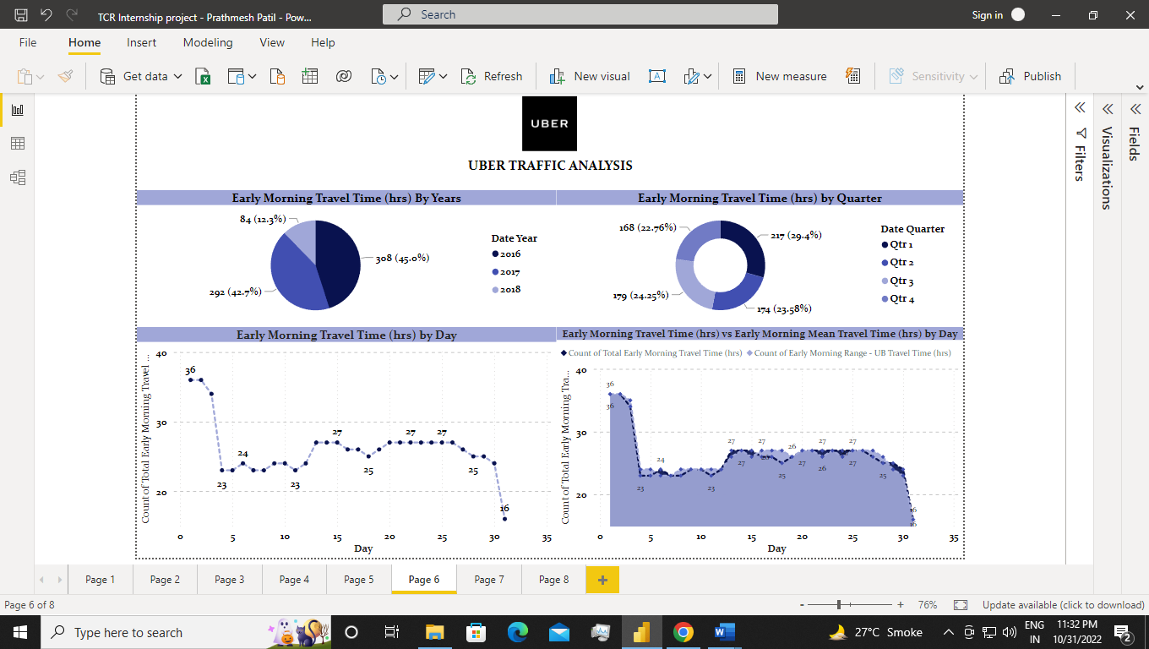

Figure

Figure

Figure

**Conclusion**

By seeing the various outputs of the dashboards it is working fine and doesn’t seems to be odd as the color of the visuals looks eye catching. The result of the dashboard is quite impressive as it compares with others fields very properly. As Microsoft Power BI is fascinating tool it is capable to have more features as I can see there would be more features can be added in dashboard visuals in future.